MBA QUARTERLY FORBEARANCE REPORT
Phase I
These reports will be used to report Quarterly Forbearance activity to the Mortgage Bankers Association. The report will need to look specifically for activity within the quarter that just ended (Jan – March, April – June, July – September, and October – December). Example: On September 30th, the report should contain all activity from July 1st through September 30th only.

The creation of these reports will be divided into 3 phases. Complete Phase I, test, validate, and when completed we will move on to Phase II, then Phase III.
You can put the reports next to Mods Completed Report on database. Name – MBA Reports
Report 1 Name Description: L605 Residential First Mortgages (1-4 Unit Residential) in COVID-19 related Forbearance that were Current when Placed in Forbearance.
This initial part of the report will look for all loans that were placed on a forbearance and were current (not past due) at that time.
We will need a breakdown of FNMA, FHA, VA, with Total UPB Amount, Loan Count, and Average Loan Size. Need to be able to export to Excel.
I see it looking similar to Mods Completed Report if that helps. I can get totals (Total UPB, Loan Count, and Average) on face of report and have a show/hide detail buttons if we need to see details. If you have a better idea, no problem with me. Just my thought.

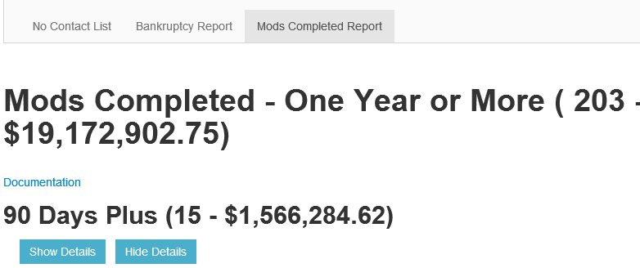
Some information needed can be found on Forbearance/Deferment Information Screen. Go to Collections, Forbearance/Deferment Summary.

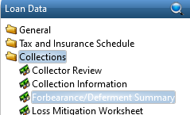

Double click on blue line/information and it will open up Forbearance/Deferment Summary shown below.
This is what screen looks like.
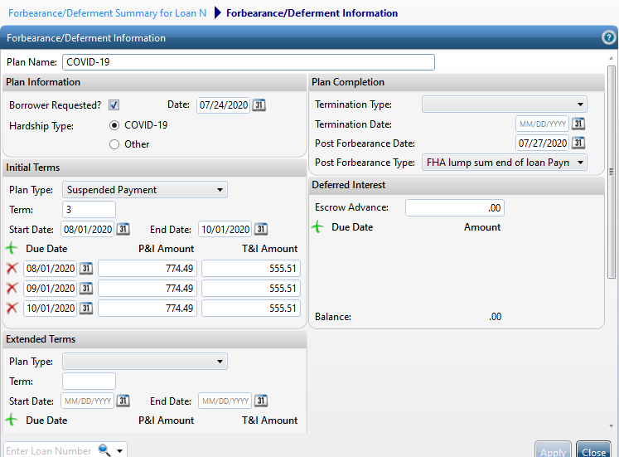
We will use the following loan as an example start to finish for this report:
Ln # 155400 – Moreno - FHA

-This is FHA loan
-Loan is current and due to 7/1/20
-Principal Balance $203,213.87

Now looking at the Forbearance/Deferment Summary Screen :

If the Plan Information Borrower Requested Date/Month (05/13/2020) is prior to or equal to the first line of the Due Date month - 07/01/2020), this will tell you if the loan was current when it was placed on a forbearance.

Also note, that the Due Date of 07/01/2020 falls within Quarter we are looking to report (July – September).

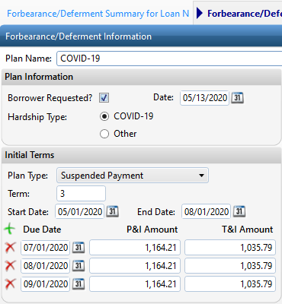

Other examples/different investor you can look at:

140924 FNMA conventional – Borrower Requested Date and Due Date match (both August).
This makes loan current when placed on forbearance.

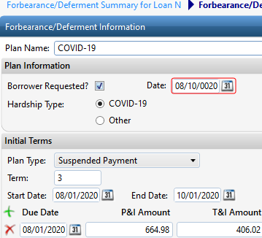

202309 VA - Borrower requested Date is prior (July) to Due Date (August).
This make loan current when placed on forbearance.

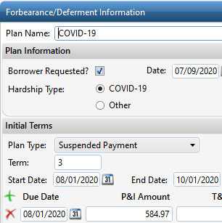

THIS IS AN EXAMPLE OF ONE THAT WAS NOT CURRENT WHEN PLACED ON FORBEARANCE.

LN#148639 FHA

Mortgagor Borrower requested date/month is 08/03/2020 and first Due Date if 06/01/2020.
The mortgagor was already 2 months past due when forbearance was requested. This loan would not
be on the listing/report as current when applied for forbearance.

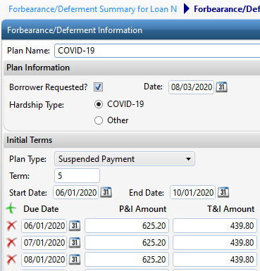

As for UPB (principal balance), I would assume getting the figure from the View History screen would work best unless you have a better idea. In this example, get UPB ($203,213.87) from last paid due date (7/13/2020) Transaction (REG).

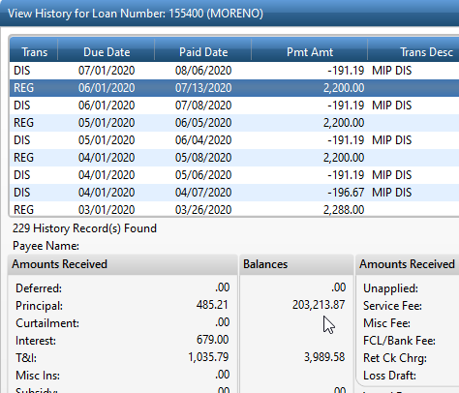

Also, all of these loans should have the same loan alerts at the bottom of page (Loan Details tab). Please program to pick up the loan on report either way, just in case we forget to populate loan alert. (Forbearance start date and due date prior/match only and/or Forbearance start date, due date prior/match, and have loan alert populated)

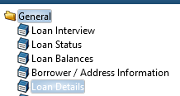

The alert is at the bottom of Loan Details page.

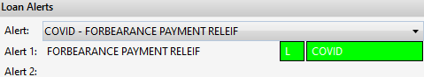

This is what the numbers looked like with the first report we did this past July for second quarter (April – June). I would expect to see Total numbers ($23,922,019.42, 194, $$123,309.38) upon pulling up report and show detail/hide detail buttons for breakdown of FNMA, VA, and FHA (See Mods Completed Report below).

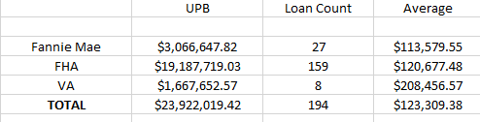

Instead of 90, 60, 30, and current, we can replace with Fannie Mae, VA, and FHA.

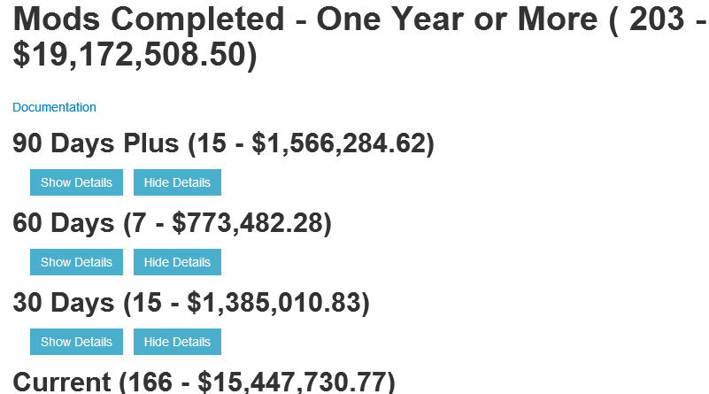

AGAIN, this is my idea of what the report will look like, but if you have a better and easier idea than do that. As long as we get to the final results, it is ok with me.

Report 2 Name Description: L606 All Other Mortgages in COVID-19 Related Forbearance that were Current when Placed in Forbearance.

This will have the same instructions as Part I.
Only Difference: Only looking for Texas Vet Loans - Loan plan: VA-TXVET
We only have 1 Texas Vet that has requested forbearance at the moment. Ln #208176

We reported 0 loans last quarter.
UPB Loan Count Average
0

Report 3 Name Description: L607 Totals Loans in COVID-19 Forbearance (current – 90 or more days delinquent) when Placed in Forbearance.
On this report, we will pick up all loans that we placed on Forbearance for that quarter (current and/or delinquent).

We will need a breakdown of FNMA, FHA, VA, with Total UPB Amount, Loan Count, and Average Loan Size. Need to be able to export to Excel.

The quarter is (July 1st – September 30th). We need to pick up everyone that requested a forbearance within this timeframe.

Look at Borrower Requested Date and pick up all loans populated with dates between July 1st through September 30th.

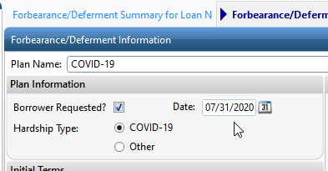

These are the numbers we reported for last quarter.

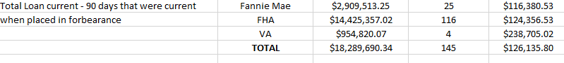

Jaime, feel free to call me if you have any questions or need explanation on my instructions.
Again, I have only made a suggestion on how the report would look like, but feel free to do it any way you want and makes it is easier for you to program.

